(Approx. 419 words)

Monitor and Protect Your Precious Data With Hard Drive Sentinel
Review by Gabe Goldberg, APCUG Representative, Potomac Area Technology and Computer Society; APCUG Advisor, Region 2
ggoldberg (at) apcug.org

Storage devices are unappreciated workhorses: spinning hard drives and immobile memory chips reliably and rapidly save and fetch your data, year after year. Until -- uh oh, something's wrong and where's my data?!

I've been running HD Sentinel (HDS -- http://www.harddisksentinel.com/) for about five
months on two computers -- my desktop system and my wife's laptop. It's a powerful tool for monitoring storage device health, and for learning more about how they work than you likely imagined possible. While the tool's website focuses on simple hard drives, HD Sentinel also supports other storage devices: SSDs, SSHD (hybrid drives), memory cards and thumb drives (where available), tape drives, and RAID controllers.
On both my systems, I've configured it to show icons for each connected hard drive: one on the laptop and three (one internal, two external) on my system. By default, the icon shows current disk temperature (with green/orange/red visually indicating status); mousing over icons displays a summary of disk health and clicking opens the comprehensive display.

Overview Display
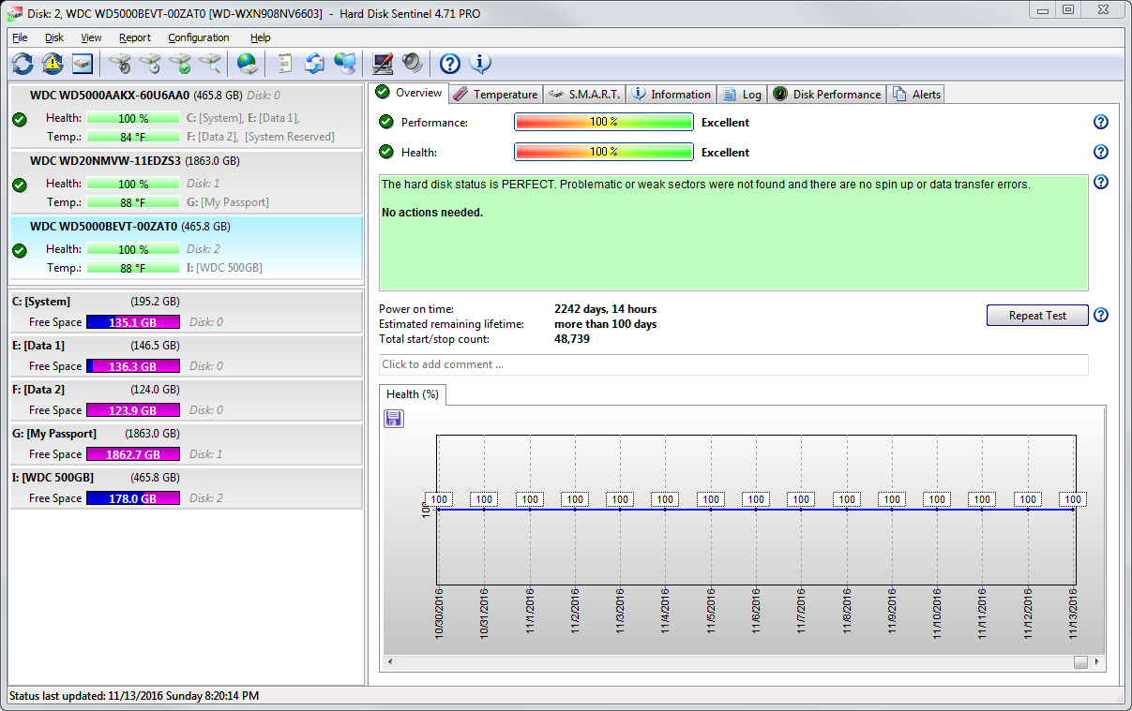

Temperature Display

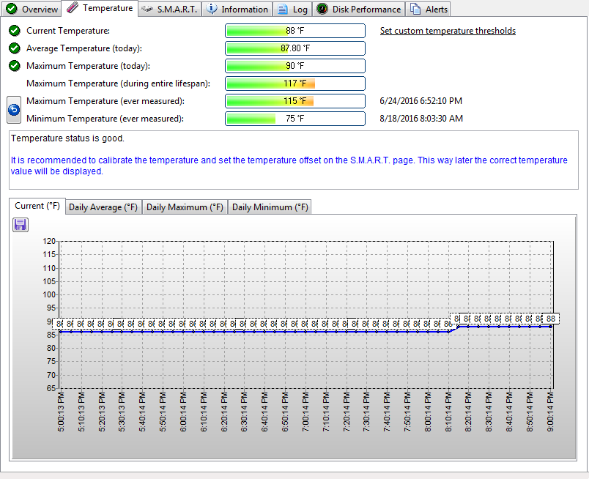

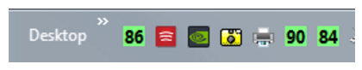

HDS can be used for maintaining one's at-a-glance comfort level (I like all my drives described, "The hard disk status is PERFECT. Problematic or weak sectors were not found and there are no spin up or data transfer errors. No actions needed.") and for drilling into drive history (temperature patterns, various sorts of errors, performance information, and more.

For many years, hard drives have included S.M.A.R.T. technology -- https://en.wikipedia.org/wiki/S.M.A.R.T. -- described as "a monitoring system included in computer hard disk drives (HDDs) and solid-state drives that detects and reports on various indicators of drive reliability, with the intent of enabling the anticipation of hardware failures". But annoyingly, most operating systems don't easily make that information -- and recommendations or warnings -- available. At least twice, based on such warnings, I've been able to replace drives in the process of failing before any data was at risk. So, I'm a firm believer in having software running to disclose drive information while there's time to act on it.
S.M.A.R.T Display
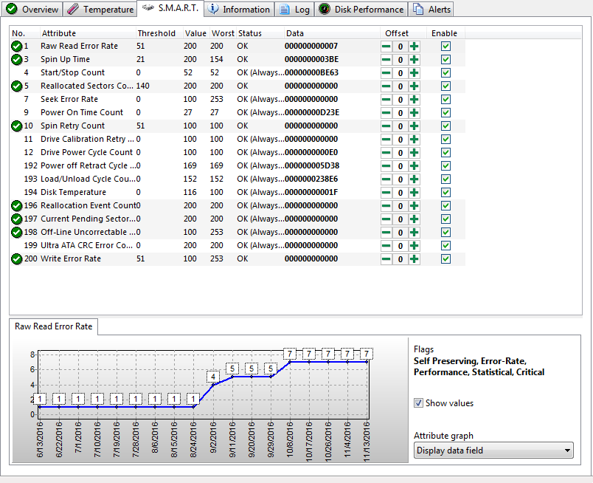

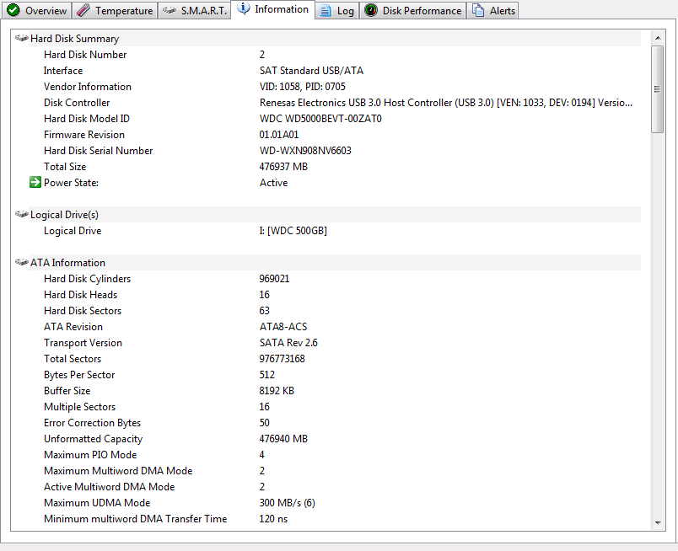

Information Display
HDS is developed/maintained/supported by a dedicated developer who's passionate about his product and brilliant at both tech support and answering questions about product usage. It's available at a bargain price for lifetime license (no renewal or subscription costs, free version upgrades) and a worthwhile investment in both knowledge and comfort.

